Kurdistan Regional Government/Iraq

Ministry of Higher Education

Noble technical institute

Department of medical laboratory

**Acritical review of rheumatoid arthritis**

Research submitted in partial fulfilment of the Requirements for the Degree of diploma in medical laboratory department in noble Technical institute

**Prepared By:**

1. **Huda Luqman Jarjis**
2. **Barez Farho Hasan**
3. **Skalla Abdulrahman Rashid**
4. **Zahra Shamall Hamid**
5. **Chra Hersh Kaka**
6. **Mohammad Abdulla Sadeq**

Supervised By: Dr.Rabar Mohammed Hussein

May/2024

**Abstract**

A general beginning and summary of our subject(Acritical review of rheumatoid arthritis ) in general, this research consists of four parts, each of which we mentioned an important aspect of our subject, first of all, our research consists of an introduction that discussed our main topic, and then the review section, which in the second part discussed the important aspect of the subject and the solutions and problems of our subject, and then we did it in the final part and we put the research resources in general

پوختە

سەرەتایەک و پوختەیەکی گشتی سەبارەت بە بابەتەکەی ئێمە**(هەوکردنی جومگەی روماتۆید)** بە گشتی ئەم توێژینەوەی ئێمە پێکهاتووە لە ٤ بەش کە لە هەر بەشێکیان ئاماژەمان بە لایەنێکی گرینگی بابەتەکەمان کردوە سەرەتا توێژینەوەکەمان پێکهاتوە لە پێشەکی کە باسی بابەتە سەرەکیەکەمان کردووە وە پاشان بەشی پێداچوونەوە کە لە بەشی دووەم باسی لایەنی گرینگی بابەتەکەو چارەسەرو گرفتەکانی بابەتەکەمان کردوە, وە پاشان لە بەشی کۆتایی ئەنجاممان داناوە وە سەرچاوەکانی توێژینەوەکەشمان بە گشتی داناوە

**ملخص**

بداية عامة وملخص لموضوعنا (مراجعة ناقدة لالتهاب المفاصل الروماتويدي) بشكل عام ، يتكون هذا البحث من أربعة أجزاء ، كل منها ذكرنا جانبا مهما من موضوعنا ، أولا وقبل كل شيء ، تتكون أبحاثنا من مقدمة ناقشت موضوعنا الرئيسي ، ثم قسم المراجعة ، والذي ناقش في الجزء الثاني الجانب الهام للموضوع وحلول ومشاكل موضوعنا ، ثم فعلنا ذلك في الجزء الأخير ووضعنا موارد البحث بشكل عام**.**

**Acknowledgment**

We would like to express our deep and utmost gratitude to our supervisor by (Dr.**RABAR MOHAMMED)** for his help, gaudiness and enragement.

We would like warmly thank all our teachers in the laboratory department for their efforts during all the years of our study.

Furthermore, we owe our beloved family a great debt of gratitude for their continual, moral and martial support, especially for our lovely parents for their support and great motivation

Table of Contents

**Abstract**

**پوختە**

**مخلص I**

**Acknowledgment II**

**Table of content** **IV**

**Chapter One: Introduction**

1.0. Introduction 1

1.1Problem Statement 2

1.2Research Questions 3

1.3Research Objective 4

**Chapter two Literature Review**

2 introductions 5

2.1 history 6

2.2 Medication7

2.3 Introduction of Epidemiology 8

2.4 The 2010 RA classification criteria 10

* 1. 1 Key differences between 1987 ARA criteria and 2010 ACR/EULAR criteria10

Etiology of of rheumatoid arthritis 13

The Diagnosis of RA15

**Chapter Three: Methodology**

3.0. introduction 16

3.1 Definition and evaluation of rheumatoid arthritis activity……………………………………..… 17

**Chapter Four**

Conclusion 19

References

**List Of Figure**

Figure 1 …………………………………………………………...………………………………… 12

**List of tables**

Table 1 ………………………………………………………………………………………………. 9

Table2 ………………………………………………………………………………11

**Chapter One**

1. **Introduction**

Introduction about rheumatoid arthritis Rheumatoid arthritis (RA) is a chronic, progressive autoimmune disease of unknown cause. It is characterized by persistent inflammation that primarily affects the peripheral joints. It usually starts as an insidious symmetrical arthritis and has an unpredictable and variable course, although pain and disability can be minimized if the condition is recognized early and treated promptly and appropriately. The disease additionally displays a spectrum of extra-articular multisystem manifestations. The worldwide prevalence of RA remains underestimated, data gathered from Western regions illustrated prevalence between 0.5 and 1% in white individuals, with prevalence rates ranging between 0.6 and 0.9% in the studied black individuals. The female to male ratio in rheumatoid arthritis is 2:1 to 3:1. A high concordance rate is observed in monozygotic twins 12–15% compared to 2–3% in dizygotic twins. Theories behind the evolution of autoimmunity in rheumatoid arthritis are clearly multifactorial. The inflammatory process usually develops in a predisposed individual who is probably exposed to a provocative trigger of autoimmunity via epigenetic modifications. 2A number of risk factors comprising genetic as well non genetic elements provide the hostile environment for the change towards autoimmunity. Evidences revealed a significant impact of familial genetic risk factors featuring ≥50% of the total risk of developing seropositive RA, with highest incidence rates among first-degree relatives. Among the most influential non genetic risk factors there comes smoking.

1. **Statement of the Problem**

The main problem with our research was the lack of a good time to write our research, and we couldn't find the specific source that the teacher wanted to find, which further delayed our work, but in the end I hope we did something to the teachers and everyone.

1. **Research Questions**

This study seeks to find the following research questions:

* 1. The reason for choosing this topic
  2. Why was this matter important to us?
  3. Is there a general treatment in hospitals for this disease?

1. **Research Objectives**

This study aims to find the following objectives:

1. This research aims to find the following objectives:
2. Protecting yourself from being infected with this disease
3. Helping and assisting those with the disease

**Chapter Two**

**Literature Review**

1. **Introduction**

A genetic predisposition (sometimes also called genetic susceptibility) is an increased likelihood of developing a particular disease based on a person's genetic makeup. A genetic predisposition results from specific genetic variations that are often inherited from a parent. These genetic changes contribute to the development of a disease but do not directly cause it. Some people with a predisposing genetic variation will never get the disease while others will, even within the same family. Genetic variations can have large or small effects on the likelihood of developing a particular disease. For example, certain variants (also called mutations) in the BRCA1 or BRCA2 genes greatly increase a person's risk of developing breast cancer and ovarian cancer. Particular variations in other genes, such as BARD1 and BRIP1, also increase breast cancer risk, but the contribution of these genetic changes to a person's overall risk appears to be much smaller. Current research is focused on identifying genetic changes that have a small effect on disease risk but are common in the general population. Although each of these variations only slightly increases a person's risk, having changes in several different genes may combine to increase disease risk significantly. Changes in many genes, each with a small effect, may underlie susceptibility to many common diseases, including cancer, obesity, diabetes, heart disease, and mental illness. Researchers are working to calculate an individual’s estimated risk for developing a common disease based on the combination of variants in many genes across their genome. This measure, known as the polygenic risk score, is expected to help guide healthcare decisions in the future.

* 1. **History of RA**

The first description of RA acknowledged by modern medicine is found in the dissertation of Augustin Jacob Lander-Beauvais from the year 1800. LanderBeauvais was only 28 years old and a resident physician at the Saltpeter asylum in France when he first noticed the symptoms and signs of what we now know to be RA. He examined and treated a handful of patients with severe joint pain that could not be explained by other known maladies at the time (such as “rheumatism” or osteoarthritis). (Landré-Beauvais, 2001)Unlike gout, this condition mainly affected the poor, affected women more often than men, and had previously been ignored by other physicians who – concerned with earning acclaim and compensation for their work – usually chose to treat more affluent patients. He hypothesized that these patients were suffering from a previously uncharacterized condition, which he named Goutte Ashanique Primitive, or “Primary Asthenic Gout.” Though Lander-Beauvais’ classification of RA as a relative of gout was inaccurate, his dissertation encouraged other researchers in the field of bone and joint disorders to further study this disease. (Kahn MF, 2001) The next important contributor to the study of RA was Alfred Garrod, an English physician during the mid to late 19th century. Alfred Garrod was the first to distinguish gout from other arthritic conditions. He found an excess of uric acid in the blood of patients suffering from gout, but not in the blood of patients with other forms of arthritis. In 1859, Alfred Garrod wrote his Treatise on Nature of Gout and Rheumatic Gout, wherein he describes these observations. This work differentiated arthritis from gout and also categorized RA as a distinct condition, which he referred to as “Rheumatic Gout.” Alfred Garrod’s discoveries laid the groundwork for research on the etiology of RA (Rheumatic Gout). If this condition could be differentiated from both gout and other forms of arthritis, then a distinct etiology must exist. (WSC., 1964)

1. **Medications**

The types of medications recommended by your doctor will depend on the severity of your symptoms and how long you've had rheumatoid arthritis.

* **NSAIDs**. Nonsteroidal anti-inflammatory drugs (NSAIDs) can relieve pain and reduce inflammation. Over-the-counter NSAIDs include ibuprofen (Advil, Motrin IB, others) and naproxen sodium (Aleve). Stronger NSAIDs are available by prescription. Side effects may include stomach irritation, heart problems and kidney damage.
* **Steroids.** Corticosteroid medications, such as prednisone, reduce inflammation and pain and slow joint damage. Side effects may include thinning of bones, weight gain and diabetes. Doctors often prescribe a corticosteroid to relieve symptoms quickly, with the goal of gradually tapering off the medication.
* **Conventional DMARDs.** These drugs can slow the progression of rheumatoid arthritis and save the joints and other tissues from permanent damage. Common DMARDs include methotrexate (Trexall, Otrexup, others), leflunomide (Arava), hydroxychloroquine (Plaquenil) and sulfasalazine (Azulfidine). Side effects vary but may include liver damage and severe lung infections.
* **Biologic agents.** Also known as biologic response modifiers, this newer class of DMARDs includes abatacept (Orencia), adalimumab (Humira), anakinra (Kineret), certolizumab (Cimzia), etanercept (Enbrel), golimumab (Simponi), infliximab (Remicade), rituximab (Rituxan), sarilumab (Kevzara) and tocilizumab (Actemra). Biologic DMARDs are usually most effective when paired with a conventional DMARD, such as methotrexate. This type of drug also increases the risk of infections.
* **Targeted synthetic DMARDs.** Baricitinib (Olumiant), tofacitinib (Xeljanz) and upadacitinib (Rinvoq) may be used if conventional DMARDs and biologics haven't been effective. Higher doses of tofacitinib can increase the risk of blood clots in the lungs, serious heart-related events and cancer.

1. **Introduction of Epidemiology**

From the existing data, some general conclusions may be drawn regarding the epidemiology of RA. The overall world prevalence of RA is approximately 0.5% to 1%, but may be declining in the United States. Using data from 1995 and 2005, the prevalence of RA in adult Americans was estimated at 1.29 million (0.6%), down from the previous estimate of 2.1 million. In 1995, the prevalence of RA in American women (1.06%) was nearly double that in men (0.61%). Interestingly, because most data were derived from patients in Minnesota, they may not be generalizable beyond Caucasians.9 There is regional variation in the prevalence of RA. The incidence appears to be highest in Pima Indians (5.3%) and Chippewa Indians (6.8%), and lowest in people from China and Japan (0.2%-0.3%), suggesting the possibility that genetic factors contribute to RA.10 These differences in regional RA prevalence also may suggest a role for environmental factors. (McInnes IB, 2011)

The exact cause of RA is unknown. The leading hypothesis for this (and most other autoimmune disorders) is that RA is the result of an environmental exposure or “trigger” in a genetically susceptible individual.11 Some environmental factors related to gender have emerged. Women who actively take oral contraceptives have a lower incidence of RA (~0.3/1000 women years) compared with women who never took oral contraceptives (~0.65/1000 women years) or those who previously took oral contraceptives (~0.55/1000 women years).10 Both female subfertility and the immediate postpartum period after a first pregnancy (especially when breastfeeding) appear to increase the risk of RA.10 Other potential environmental triggers include viral infections, such as those of Epstein-Barr virus, parvovirus, and bacterial infections with organisms such as Proteus and Mycoplasma. Heat-shock proteins and other stressors (eg, hypothalamic-pituitaryadrenal changes during adverse or traumatic life events) affect immune regulation and cytokine production.(de Pablo, 2009) Heatshock proteins create immune complexes that may trigger the production of RF.The gastrointestinal microbiome has also been implicated in triggering autoantibody production, depending on the bacteria present. Several environmental factors are capable of creating posttranslational modifications of barrier tissues through peptidyl arginine deiminase, type IV (PADI4), an enzyme responsible for post-translational citrullination of peptide antigens on arginine residues. PADI4 has the ability to alter citrullination of mucosal proteins, and it is associated with Porphyromonas gingivalis, present in periodontal disease and in patients who smoke cigarettes. Cigarette smoking appears to be associated with an increased risk of RA, and the development of a positive RF. (Turesson C, 1999)

**Table 1 (table of RA)**

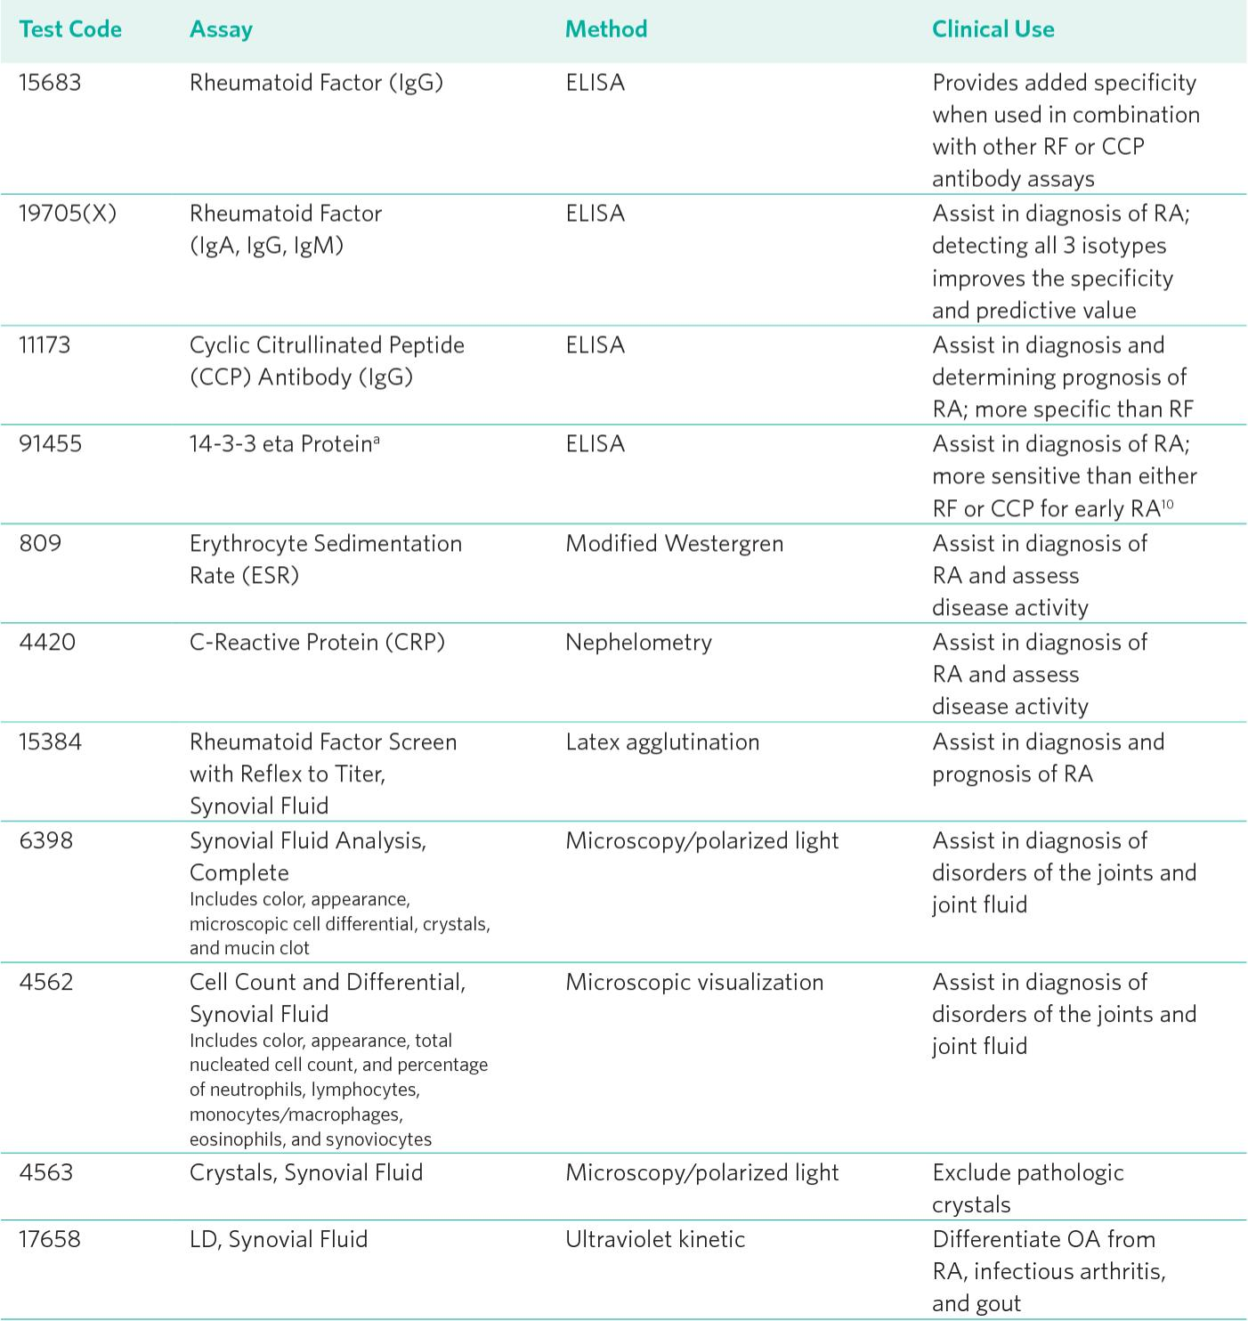

1. **The 2010 RA classification criteria:**

**Domains, categories and point scores**

The 2010 ACR/EULAR RA classification criteria (Table 2) [5] are intended to be applied to patients who present with definite swelling of at least one joint on clinical examination, for whom another diagnosis (e.g. SLE, PsA, gout) does not better account for the synovitis. Because the presence of bony erosion indicates that structural damage already has occurred, appropriate patients in whom an erosion characteristic of RA is already evident on plain radiographs are classified as having RA without applying the scoring system. Patients with long-standing disease need not have actively swollen joints to be diagnosed as having RA. If retrospective data indicate that such patients previously fulfilled the 2010 RA classification criteria, those patients may be classified as having RA regardless of whether or not they are currently receiving treatment [5]. The process by which definite RA is classified can also be illustrated as a tree algorithm (Fig. 1) [5].

* 1. **1 Key differences between 1987 ARA criteria and 2010 ACR/EULAR criteria**

In the 1987 ARA RA classification criteria, seven discrete criteria are considered. This classification system specifies that patients satisfying at least four of the seven criteria should be considered as having RA. Radiographic changes, including bony erosion and periarticular osteopenia, that constitute one of the seven criteria are not present among patients with the earliest stages of disease that are most amenable to therapeutic intervention. The only laboratory abnormality included in these classification criteria is the presence of circulating RF. Thus, patients who have circulating ACPAs but no circulating RF may not satisfy the 1987 ARA criteria. These criteria place significant weight on the presence of arthritis involving hand joints, symmetrical joint involvement and the presence of rheumatoid nodules; these features may not be present at very early stages of RA disease activity.

TABLE 2 2010 RA classification criteria: domains, categories and point scores [5]

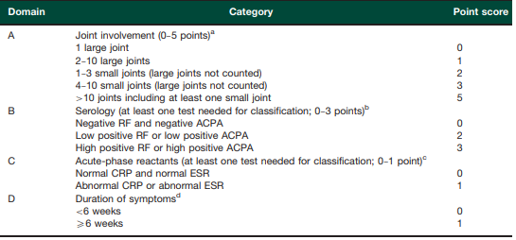

The points from each of domains A through D are added and the sum is considered to be the total score. A total score of 56 is needed to classify a patient as having definite RA. a Joint involvement refers to any swollen or tender joint on examination, which may be confirmed by imaging evidence of synovitis. DIP joints, first CMC joints and first MTP joints are excluded from assessment. Large joints refer to shoulders, elbows, hips, knees and ankles. Small joints refer to MCP joints, PIP joints, second through fifth MTP joints, thumb IP joints and wrists. b Negative means less than or equal to the upper limit of normal (ULN); low positive means >ULN; high positive means >3 ULN. c Normal and abnormal are determined by local laboratory standards. d Duration of symptoms as per patient’s self-report. Table adapted from Ref. [5] with permission of John Wiley and Sons Ltd.

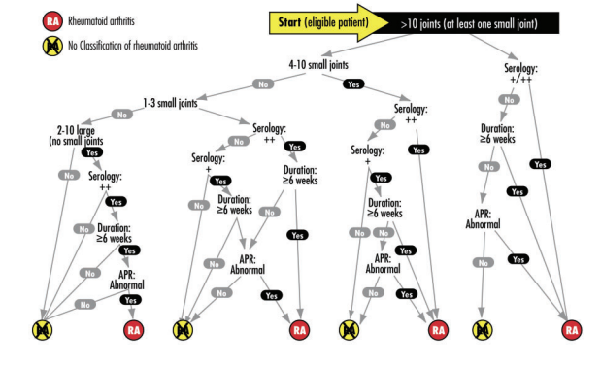

FIG. 1 Tree algorithm for classifying definite RA (red circles) or for excluding its current presence (yellow circles) [5].

by the expert panel of rheumatologists during the consensus-driven process, none of these factors (which were included among the 1987 criteria) had positive predictive value of enough weight to be included in the 2010 ACR/EULAR RA classification criteria. The initial impetus to create new RA classification criteria was to be able to include patients at the earliest stages of disease who might benefit the most from the initiation of effective therapy to prevent development of structural damage. Thus, the 2010 ACR/EULAR RA classification criteria do not include evidence of structural damage as one of the diagnostic criteria and expand the applicability of these criteria to patients with disease of Disclosure statement: The authors have declared no conflicts of interest.

1. **Etiology of of rheumatoid arthritis**

Like many autoimmune diseases, the etiology of RA is multifactorial. Genetic susceptibility is evident in familial clustering and monozygotic twin studies, with 50 percent of RA risk attributable to genetic factors. Genetic associations for RA include human leukocyte antigen-DR4. (Firestein, 2009) and -DRB1, and a variety of alleles called the shared epitope. Genome-wide association studies have identified additional genetic signatures that increase the risk of RA and other autoimmune diseases, including *STAT4* gene and CD40 locus. Smoking is the major environmental trigger for RA, especially in those with a genetic predisposition. Although infections may unmask an autoimmune response, no particular pathogen has been proven to cause RA. (llaire S, 2009)

1. **The Diagnosis of RA**

Clinically, RA patients typically present with a recent onset of tender and swollen joints, morning joint stiffness, generalized sickness symptoms (Agostino, 2016)

Timely and precise diagnosis is of high importance in RA treatment, since early diagnosis can arrest disease in many patients, thereby preventing or substantially slowing disease progression, irreparable joint damage, and disability in up to 90% of RA patients. (Prado, 2018)Typically, RA is diagnosed by a combination of patient’s symptoms, results of doctor´s examination, assessment of risk factors, family history, joint assessment by ultrasound sonography, and assessment of laboratory markers such as elevated levels of CRP and ESR in serum and detection of RA-specific autoantibodies Both ultrasound and MRI have been recommended for diagnosing and monitoring disease activity in RA patients. Ultrasound analysis (e.g., as high-resolution musculoskeletal ultrasound) of inflamed joints allows imaging of synovial proliferation by grayscale as well as both active inflammation and neo angiogenesis by power Doppler. In addition, ultrasound is able to identify bone erosions, as well as subclinical synovitis that may result in radiographic disease progression even if the patient is in apparent clinical remission. Due to these capabilities, ultrasound is widely used in clinical practice as well as in clinical trials for the diagnosis of RA and the monitoring of disease states. (Zayat & EllegaardConaghan, 2014 ) The advantages of ultrasound are its relatively low cost, wide availability, lack of contraindications, and non-invasive real-time imaging capabilities.

Disadvantages are that ultrasound is considered an operator-dependent technology because of it being training-intensive in terms of both measurement and quality assessment. While being a very sensitive diagnostic tool to detect e.g., synovial hypertrophy or pannus formation before the occurrence of bone erosion, routine usage of magnetic resonance imaging (MRI) techniques (preferably contrasted) in the diagnosis of RA is limited by cost factors and the limited capacity to image multiple joints in one measurement.

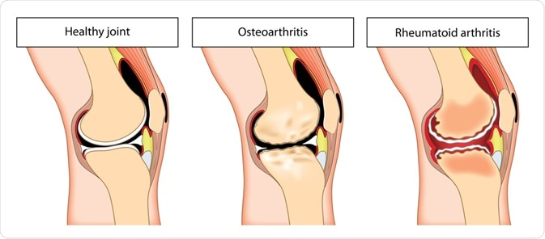

Figure two the sign of RA

1. **The Treatment Of Rheumatoid Arthritis**

The treatment of rheumatoid arthritis (RA) has been transformed with the introduction of biologic disease modifying anti-rheumatic drugs (bDMARD) and more recently, targeted synthetic DMARD (tsDMARD) therapies in the form of janus-kinase inhibitors. Nevertheless, response to these agents varies such that a trial-and-error approach is adopted; leading to poor patient quality of life, and long-term outcomes. There is thus an urgent need to identify effective biomarkers to guide treatment selection. A wealth of research has been invested in this field but with minimal progress. Increasingly recognized is the importance of evaluating synovial tissue, the primary site of RA, as opposed to peripheral bloodbased investigation. In this mini-review, we summarize the literature supporting synovial tissue heterogeneity, the conceptual basis for stratified therapy. (Nam, 2010) This includes recognition of distinct synovial pathobiological subtypes and associated molecular pathways. We also review synovial tissue studies that have been conducted to evaluate the effect of individual bDMARD and tsDMARD on the cellular and molecular characteristics, with a view to identifying tissue predictors of response. Initial observations are being brought into the clinical trial landscape with stratified biopsy trials to validate toward implementation. Furthermore, development of tissue based omics technology holds still more promise in advancing our understanding of disease processes and guiding future drug selection. (Sokka T, 2008)

**Chapter Three**

**Methodology**

.

* 1. **Introduction about Rheumatoid arthritis**

Rheumatoid arthritis, or RA, is an autoimmune and inflammatory disease, which means that your immune system attacks healthy cells in your body by mistake, causing inflammation (painful swelling) in the affected parts of the body.

RA mainly attacks the joints, usually many joints at once. RA commonly affects joints in the hands, wrists, and knees. In a joint with RA, the lining of the joint becomes inflamed, causing damage to joint tissue. This tissue damage can cause long-lasting or chronic pain, unsteadiness (lack of balance), and deformity (misshapenness).

* 1. **Definition and evaluation of rheumatoid arthritis activity**

Before developing a score, clear guidelines designed by expert physicians are needed to evaluate disease activity in order to limit inter-physician variability. Such gold standards can be related, for example, to the level of physical impairment, the type of treatment needed, etc. However, it seems that no gold standard has yet been reached for describing disease activity in RA. For example, no consensus on the definition of remission has yet been reached. Remission can currently be confirmed when the DAS28 score is lower than 2.4, or confirmed independently using the 2010 American College of Rheumatology (ACR)/EULAR criteria. Although both rules share common items, discrepancies exist and the need for guidelines has been pointed out.[21](https://www.dovepress.com/methodological-issues-in-the-design-of-a-rheumatoid-arthritis-activity-peer-reviewed-fulltext-article-CLEP#ref21) Shaver et al already reported some inconsistencies using published cut-offs for remission of DAS28 and CDAI and therefore recommend cautious use of these with patients.

The lack of guidelines was also illustrated in the study of Aletaha et al in 2005.[7](https://www.dovepress.com/methodological-issues-in-the-design-of-a-rheumatoid-arthritis-activity-peer-reviewed-fulltext-article-CLEP#ref7) In this article, 35 experts had to judge the disease activity state of 32 RA patients. No reference explaining how patients were rated by the experts was given, although objective criteria had been clearly established when setting up DAS28 earlier in Prevoo et al’s paper. Only two of these were unanimously classified in the same disease activity category by every expert: those of lowest and highest disease activity. Over the whole sample, the mean percentage of judges classifying a given patient into a group other than the majority reached 28.42%. Even if the proposed statistical analysis tried to smooth the inter-expert variability by averaging the expert specific cut-offs, it seems then somewhat illusory to hope that precise cut-offs will help to classify patients when experts in the field experience some difficulty reconciling their judgments.

Besides this, a scoring scale has to replace a gold standard that is difficult or expensive to measure directly. It has to rely on other features than the ones used to define the guidelines and to offer a comparable efficiency. For example, if the number of tender joints was used by the 35 experts as the reference test to assess disease activity, then including it in a score such as DAS28 becomes redundant.

**Chapter four**

**Conclusion**

In this research, we showed some methodological issues in developing an RA activity score and its cut-offs are reviewed and addressed. However, developing a new score following the guidelines proposed in this article could offer an alternative tool to accurately measure RA activity and could thus improve patients’ health care. Moreover, it is now very important to define a gold standard to evaluate RA activity, to collect reliable data, and to apply a relevant methodology in order to develop a valid bio clinical score to assess RA disease activity states.

**References**

1. American College of Rheumatology ad hoc Committee on Clinical Guidelines. Guidelines for the management of rheumatoid arthritis. Arthritis Rheum 2002;46:328–46
2. Tobon GJ, Youinou P, Saraux A. The environment, geo-epidemiology, and autoimmune disease: Rheumatoid arthritis. Journal of Autoimmunity. 2010;35(1)
3. Smolen JS, Aletaha D, McInnes IB. Rheumatoid arthritis. The Lancet. 2016 :2023-2038
4. Altshuler D, Kruglyak L, Lander E. Genetic polymorphisms and disease. New England Journal of Medicine. 1998;338(22):1626
5. Landré-Beauvais AJ. The First Description of Rheumatoid Arthritis. Unabridged Text of the Doctoral Dissertation Presented in 1800. Joint Bone Spine. 2001;68:130–142. [PubMed] [Google Scholar]
6. Kahn MF, Landré-Beauvais AJ. Joint Bone Spine. 2001;68:143. [Google Scholar]
7. Copeman WSC. A Short History of Gout. Berkeley and Los Angeles: University of California Press; 1964. [Google Scholar]
8. Storey GD. Alfred Baring Garrod (18191907) Rheumatology. 2001;40:1189–1190. [PubMed] [Google Scholar]
9. Mayo Clinic researchers use AI, biomarkers to personalize rheumatoid arthritis treatment Dec. 17, 2021, 04:00 p.m. CD
10. McInnes IB, Schett G. The pathogenesis of rheumatoid arthritis. *N Engl J Med*. 2011;365(23):2205-2219.
11. de Pablo P, Chapple ILC, Buckley CD, Dietrich T. Periodontitis in systemic rheumatic diseases. *Nat Rev Rheumatol*. 2009;5(4): 218-224.
12. Turesson C, Jacobsson L, Bergström U. Extra-articular rheumatoid arthritis: prevalence and mortality. *Rheumatology (Oxford)*. 1999;38(7):668-674.
13. Arnett FC, Edworthy SM, Bloch DA et al. The American Rheumatism Association 1987 revised criteria for the classification of rheumatoid arthritis. Arthritis Rheum 1988; 31:31524.
14. Aletaha D, Neogi T, Silman AJ et al. 2010 Rheumatoid arthritis classification criteria: an American College of Rheumatology/European League Against Rheumatism collaborative initiative. Arthritis Rheum 2010;62: 256981.
15. Funovits J, Aletaha D, Bykerk V et al. The 2010 American College of Rheumatology/European League Against Rheumatism classification criteria for rheumatoid arthritis: methodological report phase I. Ann Rheum Dis 2010;69: 158995.
16. Neogi T, Aletaha D, Silman AJ et al. The 2010 American College of Rheumatology/European League Against Rheumatism classification criteria for rheumatoid arthritis: phase 2 methodological report. Arthritis Rheum 2010;62: 258291. www.rheumatology.oxfordjournals.org vi9
17. D’Agostino, M.A.; Terslev, L.; Wakefield, R.; Østergaard, M.; Balint, P.; Naredo, E.; Iagnocco, A.; Backhaus, M.; Grassi, W.; Emery, P. Novel algorithms for the pragmatic use of ultrasound in the management of patients with rheumatoid arthritis: From diagnosis to remission. Ann. Rheum. Dis. 2016, 75, 1902–1908. [CrossRef]
18. Prado, A.D.D.; Staub, H.L.; Bisi, M.C.; Da Silveira, I.G.; Mendonça, J.A.; Pereira, J.P.; Fonseca, J.E. Ultrasound and its clinical use in rheumatoid arthritis: Where do we stand? Adv. Rheumatol. 2018, 58, 19. [CrossRef] [PubMed]
19. Zayat, A.S.; Ellegaard, K.; Conaghan, P.G.; Terslev, L.; Hensor, E.M.A.; Freeston, J.; Emery, P.; Wakefield, R.J. The specificity of ultrasound-detected bone erosions for rheumatoid arthritis. Ann. Rheum. Dis. 2014, 74, 897–903. [CrossRef] [PubMed]
20. Yoshimi, R.; Hama, M.; Takase, K.; Ihata, A.; Kishimoto, D.; Terauchi, K.; Watanabe, R.; Uehara, T.; Samukawa, S.; Ueda, A.; et al. Ultrasonography is a potent tool for the prediction of progressive joint destruction during clinical remission of rheumatoid arthritis. Mod. Rheumatol. 2013, 23, 456–465. [CrossRef] [PubMed]
21. Nam J, Winthrop K, van Vollenhoven RF, Pavelka K, Valesini G, Hensor E, et al. Current evidence for the management of rheumatoid arthritis with biological disease-modifying antirheumatic drugs: a systematic literature review informing the EULAR recommendations for the management of RA. Ann Rheum Dis. (2010) 69:976–86.
22. Sokka T, Hetland ML, Mäkinen H, Kautiainen H, Hørslev-Petersen K, Luukkainen RK, et al. Remission and rheumatoid arthritis: data on patients receiving usual care in twentyfour countries. Arthritis Rheumat. (2008) 58:2642–51.
23. Behrens F, Tony HP, Alten R, et al. Development and validation of a new disease activity score in 28 joints-based treatment response criterion for rheumatoid arthritis. Arthritis Care Res (Hoboken). 2013;65(10):1608–1616.
24. Gaujoux-Viala C, Mouterde G, Baillet A, et al. Evaluating disease activity in rheumatoid arthritis: which composite index is best? A systematic literature analysis of studies comparing the psychometric properties of the DAS, DAS28, SDAI and CDAI. Joint Bone Spine. 2012;79(2):149–155.
25. Hamdi W, Néji O, Ghannouchi MM, Kaffel D, Kchir MM. Comparative study of indices of activity evaluation in rheumatoid arthritis. Ann Phys Rehab Med. 2011;54(7):421–428.
26. Fransen J, Moens HB, Speyer I, van Riel PL. Effectiveness of systematic monitoring of rheumatoid arthritis disease activity in daily practice: a multicentre, cluster randomised controlled trial. Ann Rheum Dis. 2005;64(9):1294–1298.
27. Prevoo ML, van’t Hof MA, Kuper HH, van Leeuwen MA, van de Putte LB, van Riel PL. Modified disease activity scores that include twenty-eight-joint counts. Development and validation in a prospective longitudinal study of patients with rheumatoid arthritis. Arthritis Rheum. 1995;38(1):44–48.
28. Steyerberg EW. Clinical Prediction Models: A Practical Approach To Development, Validation, And Updating. New York: Springer; 2009.